**When a patient leaves hospital, follow these steps to deactivate the patient account. You should use your sites administrator account.**

1. Log in to the Aetonix Dashboards at https://dashboards.aetonix.com/ On the login page, log in using one of your institution’s aTouchAway admin logins.

2. Under the User Management section, go to **Creation/Token**. 

3.You will be presented with a full list of the patients that have been created in the Aetonix System using the aTouchAway app. Search for the patient to be deactivated using the search bar at the top, then click on the Edit button

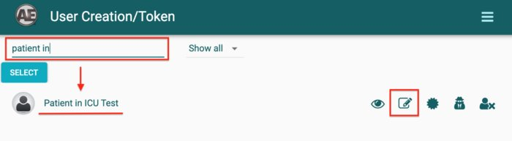

4. Under User Active State, choose “User is not active”. Click Save when done.

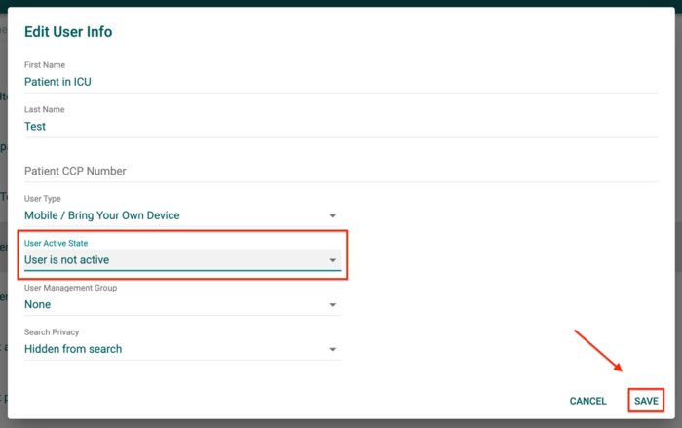

5. You will receive a warning for your confirmation. Click **YES** to disassociate the patient account from all the tablets in your site.

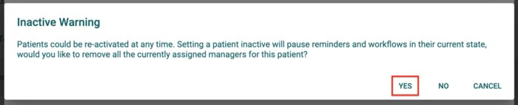

6. The patient will be marked red and will disappear from your list of Managed Users in the aTouchAway app.

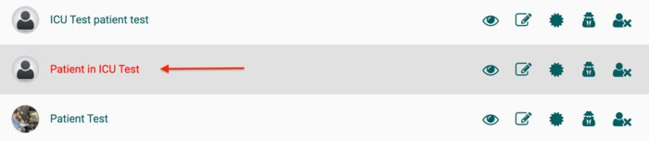

**Deactivating patient accounts**