Advice for family members on setting up and using aTouchAway for the ICU diary on their own devices

- If you have used aTouchAway before for virtual visiting, you do not need to register again. The ICU staff will be able to find your account on the aTouchAway app and will send you a notification. Move to point 8 in the instructions

- If you are new to aTouchAway, firstly download the Aetonix aTouchAway app from Google Play for Android phones/tablets or the App store for iPhones/tablets

On an Android phone/tablet, go to the play store. Type ‘aTouchAway’ in the search box and the Aetonix aTouchAway app should appear. Click on Aetonix aTouchAway Mobile app and then click Aetonix aTouchAway install. Accept the Aetonix Licence agreement and click ‘Register aTouchaway’.

On an iphone/ipad, go to the App store. Type ‘aTouchAway’ in the search box and the Aetonix aTouchAway app should appear. Click on the download icon. An Apple ID and password will be required. Accept the Aetonix Licence agreement and click ‘Register aTouchaway’

- Once the app is downloaded, complete the form to set your password (see image below). Your first name, and last name will need to be entered as well as your email address and a password.

Please register the account under your full name. This makes it easier for the ICU staff to find your user details and add you as a contact. Also register with an email account this is regularly used. It is important to remember the password, so make a note of it somewhere safe.
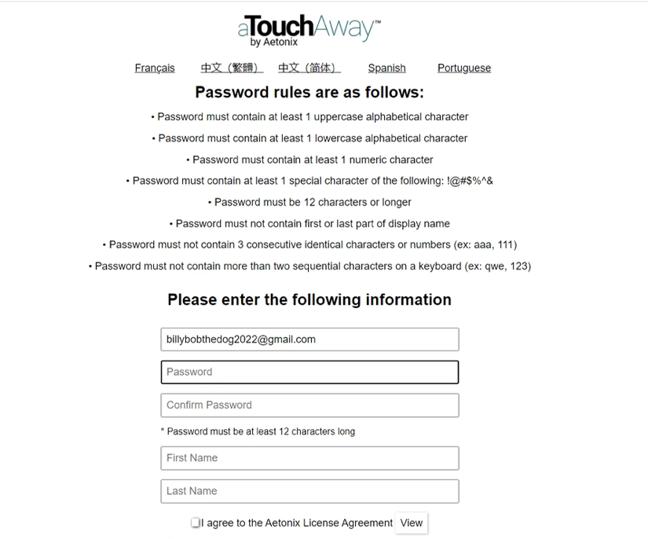

- The following pop up will appear informing you that an email has been sent. Open this email (check your junk folder as it may go there), and follow the instructions provided.
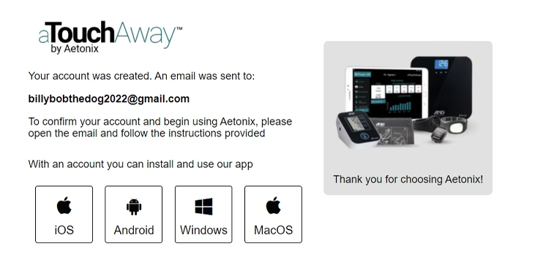

- It will ask you to click a link to validate the account. Once done this image will appear, thanking you and informing you your email has been validated.

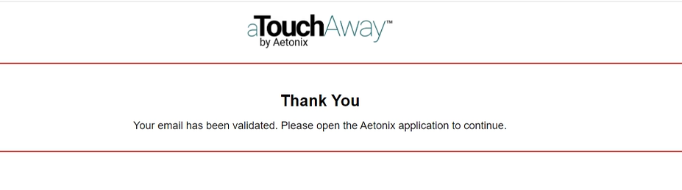

- Go to the app, and sign in as image below, with your email address and password created earlier.

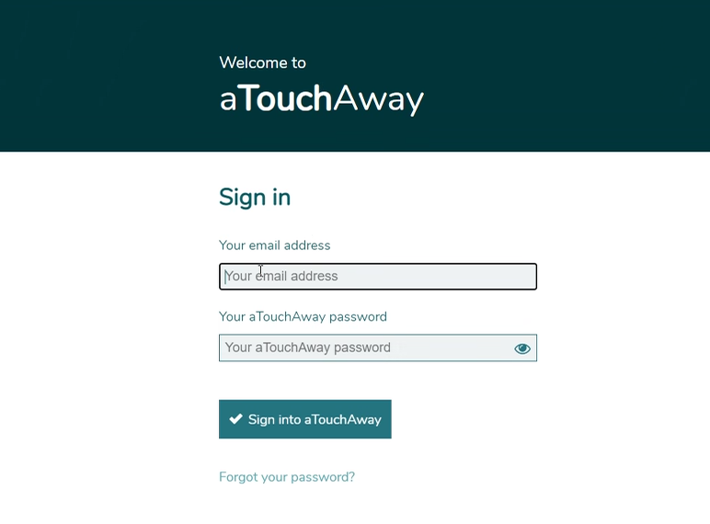

- Once logged in to the aTouchAway app, your relative’s name will appear under the heading of ‘Your Managed Users’. Click on your relative’s name to access the ICU diary. There should only be one name under ‘your managed user’. Now go to instructions no. 10.

- If you have used the aTouchAway app before and already registered, the next time you log in, you will see the following box, with a ‘managed request’ of the name of their relative. Click on ‘accept’.

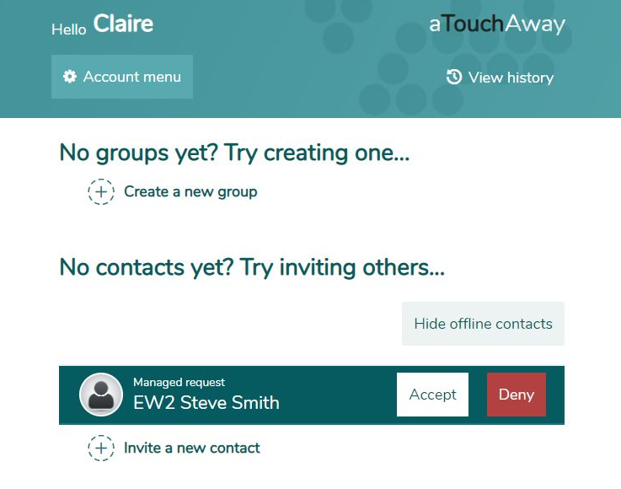

- Once ‘Accept’ has been pressed, your relative’s name will appear under the heading of ‘Your Managed Users’. Click on your relative’s name to access the ICU diary. There should only be one name under ‘Your managed user’

- Click on ‘My ICU Diary’ in ‘Forms’ to open the ICU diary

- A form will appear as shown in the image below, with the heading ‘MY ICU Diary – Create new submission’. This allows you to create a new ICU diary entry.

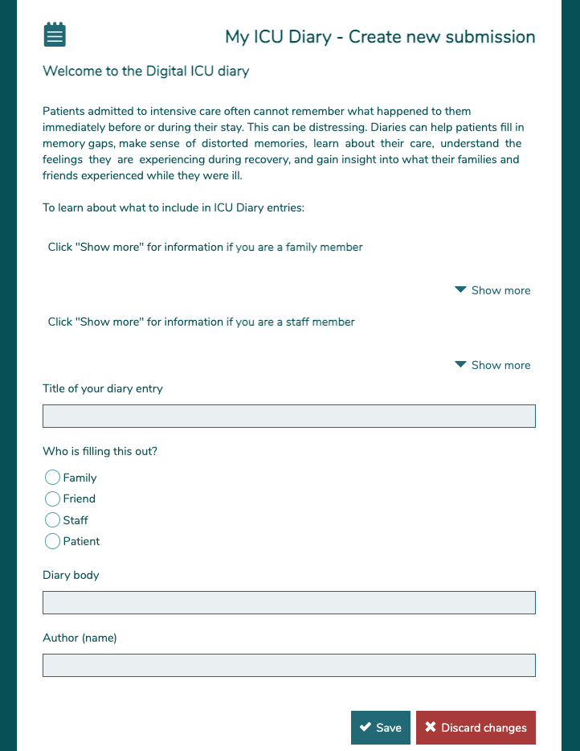

- Below are some suggestions as to what to include in an ICU diary entry. Click ‘Show more’ for examples as shown below
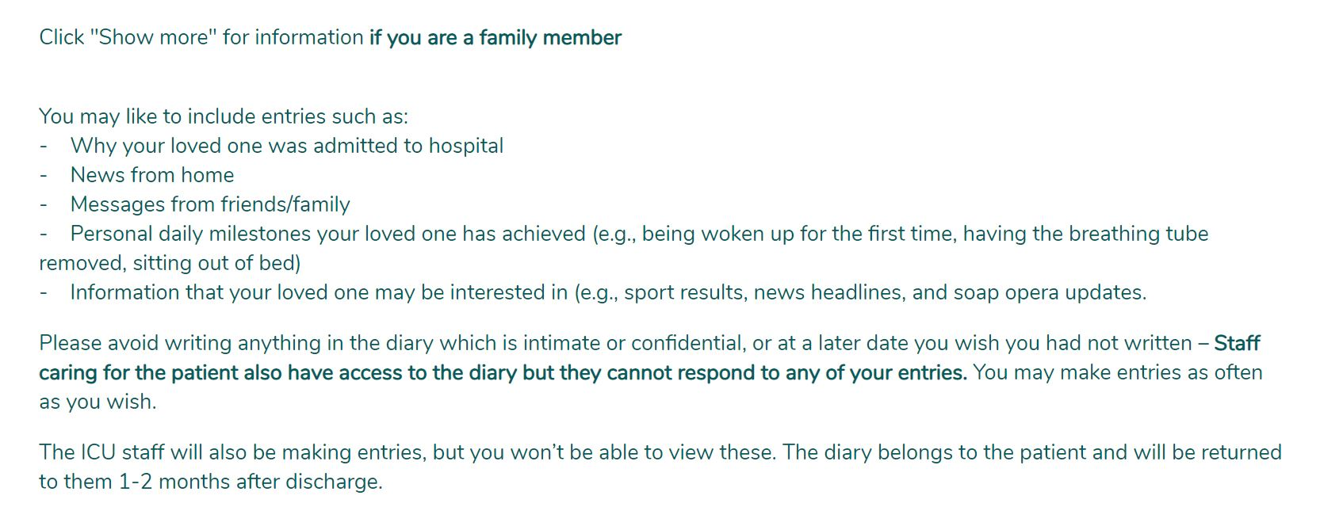

- When you have finished typing your ICU diary entry, click the ‘save’ button on the bottom of the form and your ICU diary entry is complete.

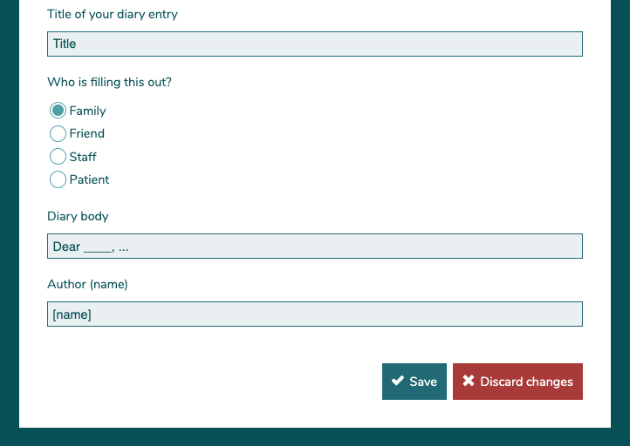

- This is how the entry will appear, on the app once saved.

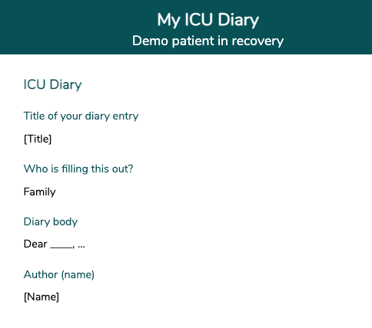

- To make new diary entries click ‘Create new submission’

- Family members are not able to view ICU diary entries made by staff or by other family members, only their own entries. The ICU diary belongs to the patient and will be returned once the patient has left the ICU.

