ICU e-diary troubleshooting guide

This guide will provide you with ways to solve problems when the ICU e-diary is not working correctly

- Locked Screen
If you are experiencing an issue with the app that means you are unable to move on from the start-up screen, or you are seeing the black screen below, it is possible someone used the “Control” feature in the app but did not use it properly. To exit out of this user interface, and go back to the usual ICU e-diary app, follow the instructions below

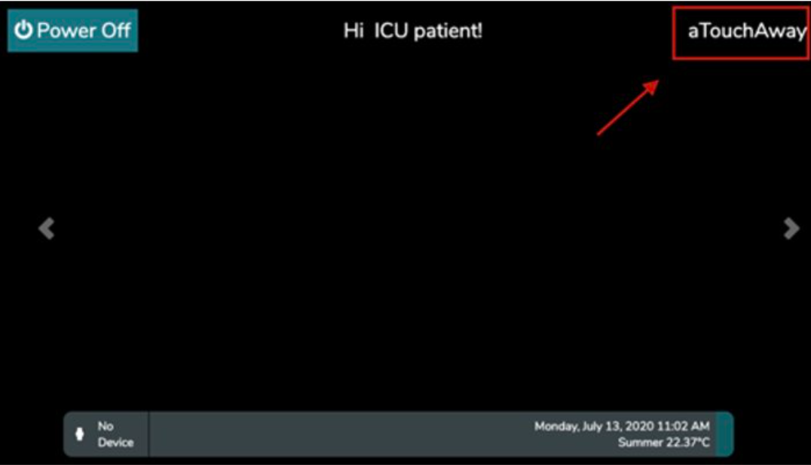

To exit this setting:

- Click on aTouchAway logo on the top right-hand corner of the screen.
- If there is no aTouchAway logo, which may be the case on smaller devices, click on the time section at the top-right corner. Sometimes there may be a logout symbol on the righthand corner as well- either way click on that button.
- Enter the password aetonix456 (and not your user account password) and click on the Unlock Setting
- Click on 'log out'
- Re-log into the tablet account with your account username icudiarystaff@xxxx.icu and the account password and click 'save'.

- No ICU e-diary functions

When you check for a patient’s user profile, if the patient’s user profile appears with basic setting and no e-diary form visible, it means whoever created that patient’s user profile set it up incorrectly. This happens when are creating the new profile at its initial stage. An incorrect patient profile will appear with no ICU diary form and no access to the Care Team tab under the Utilities section either.
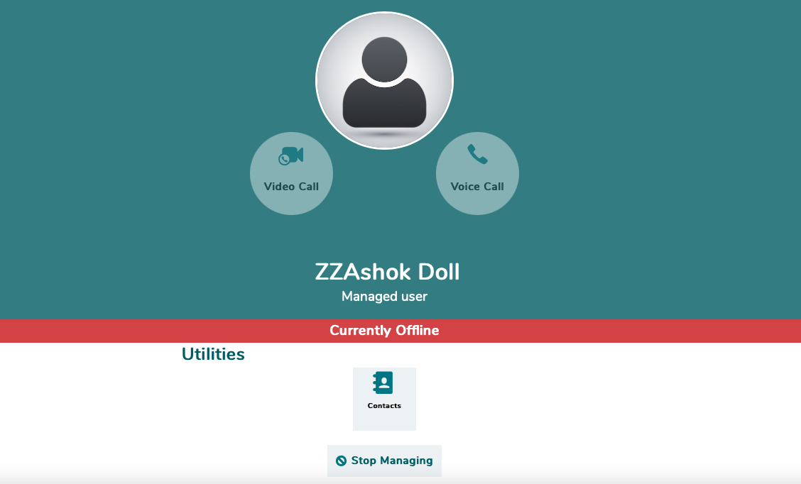
Steve Smith

- To correct this, go back home page and create a new user profile for that patient again without the diary function (see staff user guide for further details). When creating a new user profile, at the bottom of page, there is a heading called Default Managers. Do not ignore this tab as this is where you must add the ICU Diary Staff (Nursing/MDT) account as the default manager. This will allow the patients profile to be created with the e-diary function included.

- To get rid of the old profile without the e- diary function, look at the bottom of that old profile, where it has the Stop Managing button. Click on this button to delete the old profile with no diary. This will remove the old incorrect profile from being visible on the homepage. Speak with administrators at your institution to delete the old profile permanently from the app’s server.
- Putting family contacts in the wrong place

Patients’ family relatives can be added as a contact to give the relative access to Virtual Visiting calls and access to the e-diary. However, when adding the patient’s relative, be sure to double check where you are adding a family contact to! Adding a family contact must be done inside the patient’s user profile, not on the main ICU Diary Staff homepage.

- This picture is the ICU Diary staff homepage. There is visible plus tab which states: ‘Invite a new contact’. However, DO NOT add any contacts on this tab- this is NOT the area to add any family contacts.
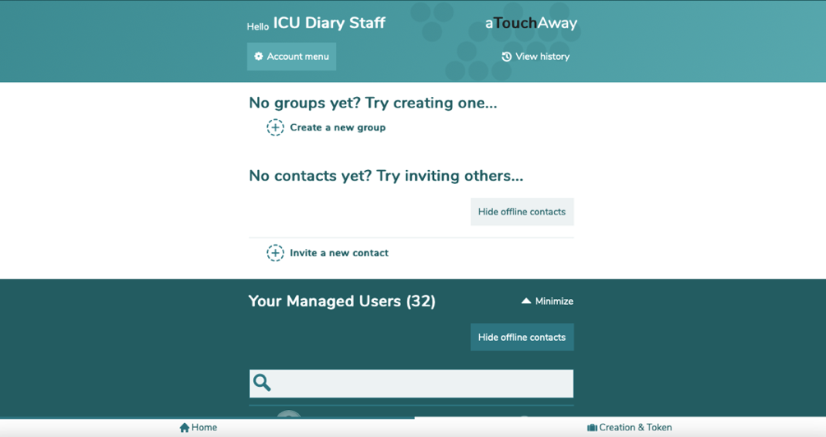

- To add a family member’s contact onto their relative’s e-diary, you need to find the patient’s user profile and look under the Utilities section. It is in that section that you add a family contact to. There are two tabs under the utilities section; the Care Team View/Manage and Contacts. The contact’s tab is where you add a family contact to permit Virtual Visiting calls and the Care Team View/Manage tab is where you add family relatives to permit usage of the patient’s e-diary.

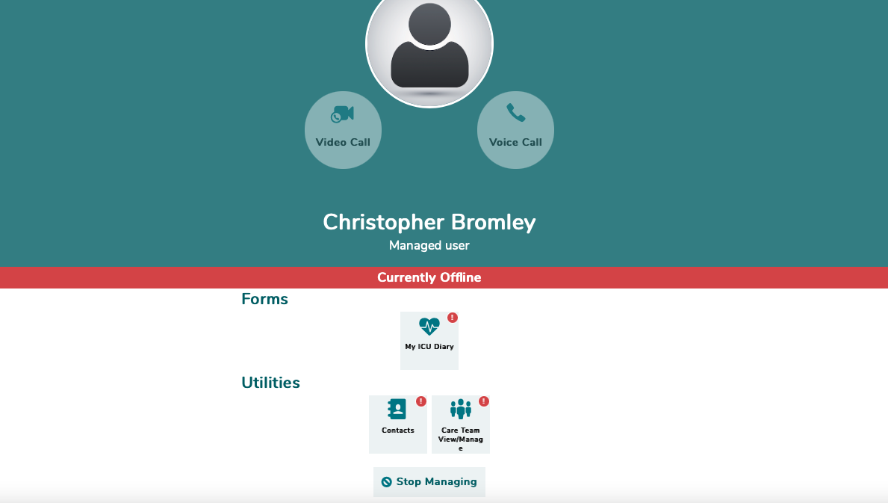
Steve Smith
For the e-Diary
For Virtual Visiting

- Unable to log in

If you are experiencing an issue with logging into the app it may mean that you may be logged into the wrong region. The application works in three different regions; United Kingdom, Canada and United States. The website and application has to be set into the U.K region for users to log in. These pictures demonstrates what may appear when you first access the website. Be sure to set the correct region to the United Kingdom any time you wish to log in aTouchAway.

